BUMK 744 Marketing Research and Analytics Spring 2026
Team Assignment 1 Follow-Up
______________________________________________________________________________

Case A: Neutral Synthetic
Content Generated: synthetic_neutral.csv
AI Used: Claude
(Provided AI with file “Survey Schema.qsf.docx” - a comprehensive overview of the survey questions and answer choices, but not providing any data seeding)
Prompt: “You are a data generator tasked with creating 500 synthetic survey responses based on the provided Qualtrics survey schema. The survey focuses on internship reporting behavior, awareness and perceptions of Career Services (OCS), incentives for reporting, communication preferences, and student demographics at the University of Maryland. Your goal is to produce realistic, internally consistent responses that reflect plausible variation across student respondents and realistic language.
Do not use any real data, prior datasets, or examples to seed the generation. All responses must be fully synthetic and independently generated. Follow the question formats, response options, and any logical branching implied by the survey structure. Ensure consistency across related answers (e.g., only respondents who indicate they completed an internship should meaningfully answer follow-up questions about reporting). Include demographic diversity and variation in attitudes.
Return the output as a CSV file with 500 rows and the following columns: Response ID, Response Date, All survey question variables, Demographic / background variables (as applicable). Response IDs should be unique, and response dates should be realistic and spread over recent months. Answers on the CSV should be written in words using the selection options (ex: “it takes too much time”), and open answer texts should be unique across all 500 responses.”

Case B: Hybrid Seeding
Content Generated: synthetic_seeded.csv

AI Used: ChatGPT
Prompt: The above documents are from step one, and I am working on step two. The prompt is what I need to answer, so please make sure to address the specific prompts to meet the class requirements. “The uploaded Excel file contains survey responses from 20 students regarding their internship and job placement reporting behavior to the Office of Career Services (OCS). It includes multiple spreadsheets with descriptive statistics. First, analyze the results from this file. Identify natural strata in the data, such as: • Sentiment groups toward OCS (positive, negative, neutral); • Engagement levels (e.g., high vs. low OCS usage, such as appointments, workshops); • Linguistic clusters (e.g., high analytical tone, high emotional tone). Then, imagine you are students with different characteristics and generate 500 survey responses regarding internship/job placement reporting to OCS. 1. Use a sampling strategy that mirrors the real response distribution (e.g., if real data shows 40% delayed reporting, generate synthetic responses with similar proportions). 2. Generate synthetic responses across the identified strata while controlling for: Sentiment toward OCS (positive, negative, neutral), adjusting tone accordingly. Reporting timing behavior (immediate vs. delayed vs. non-reporting). Response length and structure, controlling word count (WC), and sentence complexity to match observed student patterns. Pronoun usage, inducing variation (e.g., “I” for personal responsibility, “we” for collective identity, “they/OCS” for distancing or dissatisfaction). Psychological markers, such as analytical thinking, authenticity, and emotional tone, are consistent with the real data distribution. Meanwhile, ensure to generate the following variables for each of the 500 respondents and put all the generated data into an Excel file for download: • Response ID • Response Date • All survey question variables • Demographic / background variables (as applicable).” Deliverable: Spreadsheet containing all 500 responses generated (synthetic_seeded.csv)

Case C: Digital Twin Pooling
Content Generated: synthetic_digitaltwin_pooled.csv

AI Used: ChatGPT
Prompt: I am working on an assignment based on the paper “Database Report: Twin-2K-500: A Data Set for Building Digital Twins of over 2,000 People Based on Their Answers to over 500 Questions.” I have uploaded two files: a pilot survey dataset (real_data.csv) and the survey schema document. My task is to create a synthetic dataset using a Digital Twin–inspired approach. The assignment requires me (1) to analyze the pilot survey dataset (~20 responses), (2) identify strata such as timing groups, sentiment categories, and engagement levels. (3) Estimate general response variability patterns (e.g., response extremity, sentiment balance, text length variation) inspired by the Twin-2K-500 methodology. (4) Generate 1,000 synthetic survey responses where: (1) strata proportions come primarily from the pilot dataset. (2) Response variability (“noise”) reflects realistic human behavior patterns, and (3) export the final dataset as synthetic_digitaltwin_pooled.csv. Can you guide me through the steps and provide Python code I can run in Google Colab to: (1) load and analyze the pilot dataset, (2) create timing, engagement, and sentiment strata, (3) generate synthetic responses based on the strata distribution, (4) introduce realistic variation in Likert responses and completion time, and (5) export the final dataset as a CSV file?

Analysis and Reflection: Exploring Synthetic vs. Human Data

The datasets each compose various elements of personified behaviors in order to create effective predictions based upon various scenarios. The human dataset indicated the highest amount of variability across all metrics, highlighting emotional tone and analytical thinking. The neutral synthetic dataset suggested compressed distributions with lower standard deviations with decreased noise and more uniformity amongst responses. The seeded synthetic dataset slightly restored variability, while aligning closely to human response patterns without full dispersion indicated in the “real_data.”

The human dataset shows a high level of variability across a few dimensions. For instance, response times appear to range from very long periods to a number of seconds. With this type of real-world data, one would expect to see these variance levels because behavior is not predictable or uniform amongst respondents. Respectively, it is possible that some rushed through, others took their time, and some of the respondents simply left the survey open for a long period before completion. Although the human dataset certainly indicates more extreme values with increased variance, the small sample size still leaves results to be cautiously interpreted. Generally speaking, the observed variability and weak correlations do appear to be consistent with expected human behavior.

The “synthetic neutral” dataset, despite including a range of responses across categories, appears more structured and consistent overall than the real dataset, with seemingly fewer irregular or extreme patterns across the board. The dataset indicates lower variance, with values that appear more controlled overall. Essentially, a visual inspection of the dataset fails to invoke the same sense of extreme variation that is immediately apparent in the human dataset. This leads one to conclude that the data does not fully mimic the same level of extreme or irregular variation that exists in real-world settings.

If we look at the “synthetic seeded” dataset, one of its more readily observable characteristics is that the completion times seem far more plausible and fall within a believable range. Moreover, one can quickly deduce that the dataset is deliberately engineered with consistency in mind, showing no irregularities in completion amongst respondents. While this produces a more plausible surface-level pattern than the “synthetic neutral” dataset, it remains controlled and predictable in a sort of “too perfect” or uncanny way. Note that with the real data, we saw durations ranging from 78,060 seconds to just two seconds. There is nowhere near that same time disparity in the “synthetic seeded” version. At a high level, one takeaway here is that AI models have a tendency to overcorrect for perfection and deliberate fulfillment of data aggregation rather than replicating the idiosyncrasies of human behavior.

The “digital twin” dataset is interesting because it makes an attempt to restore some of the variability seen in the real data. It is partially successful in this regard as the data itself does look more varied and unpredictable. The variation in question also results in numerous unique factors including negative minutes being listed under the “completion” category. Obviously, this would be impossible in an actual survey with human participants. We can conclude that it makes an effort to replicate the depth and range of real data without fully taking into account the requirements of real-world surveys.

The synthetic datasets demonstrate significantly lower variance in comparison to the human dataset, which indicates that AI-generated responses can decrease noise. Large Language Models (LLM’s) are strengthened by effective prompt engineering based upon the prediction based nature. LLM’s often produce more consistent outputs unless guided through seeding. The observed correlation patterns in the synthetic datasets indicated increased structure and strength in comparison to the human dataset. Human responses can ultimately be extremely unpredictable which reflect real-world inconsistencies and cognitive variance.

The neutral synthetic dataset produced a small number of extreme values, with fewer instances of variation in scores across key metrics. The seeded approach partially slightly reduced this issue with increased variation, although extremes remain less frequent in the real dataset. The open-ended aspect of the survey resulted in repetitive results with inconsistent phrasing while the synthetic dataset was generally more grammatically structured and slightly repetitive due to the irregularities of human input. The neutral synthetic dataset produced mostly homogeneous responses with reduced variance and fewer extremes. The seeded synthetic dataset showed realistic improvements by incorporating structured patterns from the real data, contributing to more representative distributions. The opportunity for replicating the unpredictable and inconsistent aspects observed in the human responses were not demonstrated in the synthetic datasets.

Appendices

Figure 1: Descriptive Statistics (real_data)
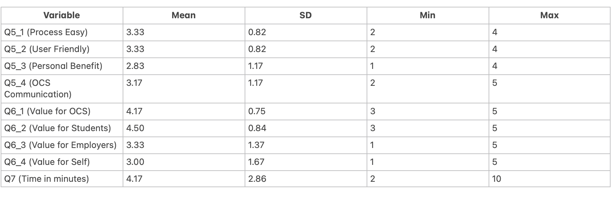
Figure 2: Correlations (real_data)

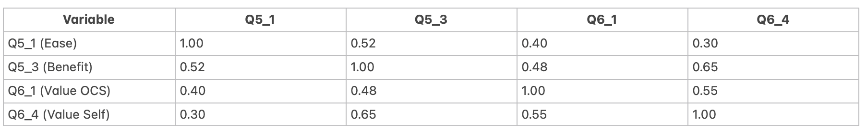

Figure 3: Descriptive Statistics (synthetic_digitaltwin_pooled)

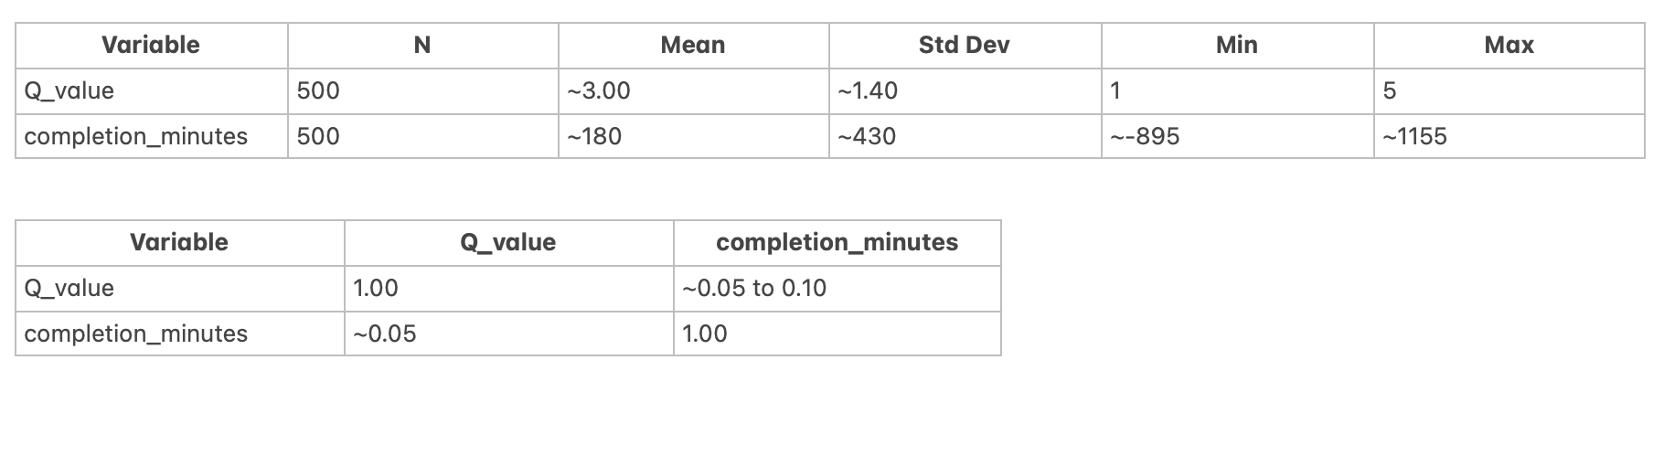
Figure 4: Correlations (synthetic_digitaltwin_pooled)



